Hi Ben – I figured it out! We can automatically pick the latest date from the data after refreshing it.
For this, we need to have 4 steps:
- We have to use Google Sheet (as Looker Studio, had some issues in joining keys for blending data), by adding new column “max_Set”.
=MAX(A:A)
This formula selects the maximum of Settlement (‘A’) column

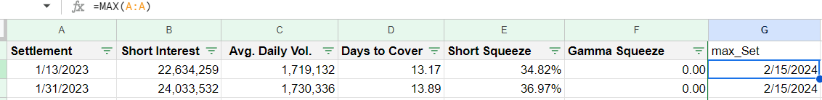

- Then, we can assign a CASE statement in the Looker studio calculated field.
So, this statement says, whenever the added column max_Set equals existing Settlement column, if it is so, then Yes, or else No
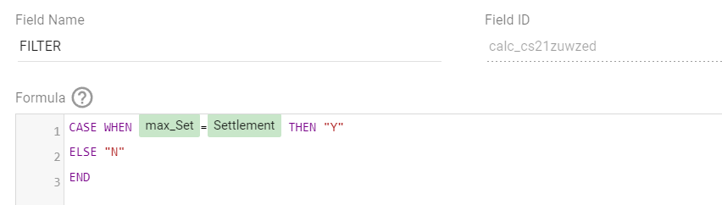

- Then, we can create a new filter in the Looker Studio, by filtering only the “Yes” values
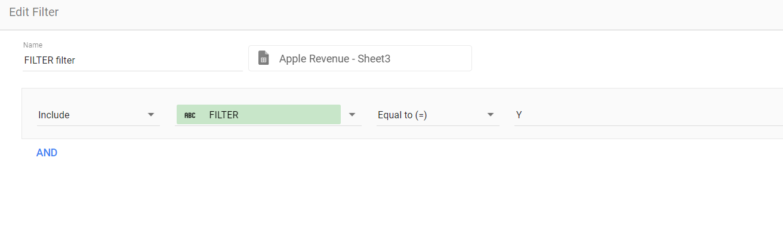
- This, will give me the required rows of data (we can check it using the “Short Interest” column, as data changes automatically) as per the latest date. You can refer the picture below:
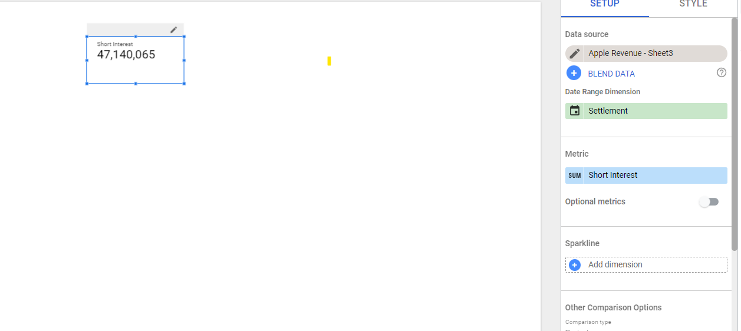

Hope, it helps!

